МІНІСТЕРСТВО ОСВІТИ І НАУКИ УКРАЇНИ

НАЦІОНАЛЬНИЙ ТЕХНІЧНИЙ УНІВЕРСИТЕТ

«ХАРКІВСЬКИЙ ПОЛІТЕХНІЧНИЙ ІНСТИТУТ»

Кафедра «Програмна інженерія та інформаційні технології управління»

Звіт з лабораторної роботи №4

З предмету «Мережеві технології»

Виконав

Студент групи КН-36а

Рубан Ю.Д.

Перевірив:

Кондратов О.М.

Харків

2017

**Тема:** Маршрутизаторы и применение статической маршрутизации в локальных вычислительных сетях

**Цели:** Лабораторная работа преследует цели закрепления теоретического материала по назначению и принципам функционирования маршрутизаторов в сетях ЛВС. Исследуются процедуры применения статической таблицы маршрутизации, в пределах нескольких сегментов локальной вычислительной сети.

**Задачи:** Согласно схеме подключений удаленных узлов, изображенной на рис.[13](https://docs.google.com/document/d/1YuZUhCSaK_EO0ZVDz6Fxw9HgFxk1KU8q2VoDt7TnD5A/edit#bookmark=id.vx1227), необходимо спроектировать виртуальную сеть и расположить коммутационное оборудование — коммутаторы и маршрутизаторы. Далее следует произвести структуризацию сети на три маршрутизируемых сегмента, воспользовавшись доступными маршрутизаторами. Для корректного функционирования сегментов сети произвести конфигурирование IP-адресов рабочих станций и соответствующих интерфейсов маршрутизаторов.

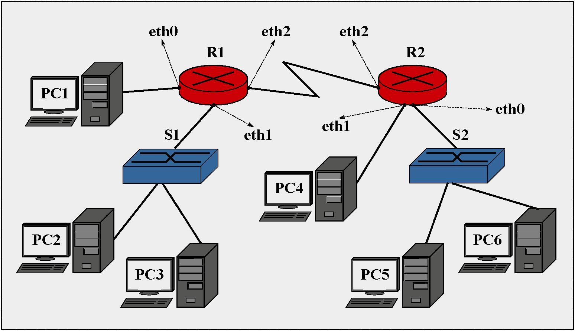

Рис. 13. Топология виртуальной сети 4

1. В соответствии с планом на рис.[13](https://docs.google.com/document/d/1YuZUhCSaK_EO0ZVDz6Fxw9HgFxk1KU8q2VoDt7TnD5A/edit#bookmark=id.vx1227), разместить указанные виртуальные устройства: **«Маршрутизатор» (2 шт.), «Коммутатор»** (2 шт.) и узлы удаленных рабочих станций PC*\ -* PC*б.* Произвести объединение узлов, используя соответствующие порты сетевого оборудования и отрезки кабеля **«Патчкорд».**
2. Рабочей станции PC1и соответствующему порту маршрутизатора *R1* **(eth0)** необходимо назначить IP-адреса из диапазона 91.122.40.4/30.
3. Для назначения IP-адресов узлам PC2 и *PC3,* а также соответствующему порту маршрутизатора *R1* **(ethl),** следует использовать адреса из диапазона 1 табл.[3](https://docs.google.com/document/d/1YuZUhCSaK_EO0ZVDz6Fxw9HgFxk1KU8q2VoDt7TnD5A/edit#bookmark=id.28h4qwu) (команда ifconfig).

1. Рабочей станции PC4и соответствующему порту второго маршрутизатора R2 (ethl) необходимо назначить IP-адреса из диапазона 91.122.40.8/30.
2. Аналогично, для назначения IP-адресов узлам *P*C5и PC6*,* а также соответствующему порту второго маршрутизатора R2 (eth0), следует использовать адреса из диапазона 2 табл.[3](https://docs.google.com/document/d/1YuZUhCSaK_EO0ZVDz6Fxw9HgFxk1KU8q2VoDt7TnD5A/edit#bookmark=id.28h4qwu).
3. Интерфейсу eth2 первого маршрутизатора *R1,* а также интерфейсу eth2 второго маршрутизатора R2 необходимо назначить IP-адреса из диапазона 91.122.40.0/30.
4. С помощью эмулятора терминала, использовать команду route и установить правила статической маршрутизации для всех непосредственно подключенных и удаленных сетей на маршрутизаторах *R1* и R2.
5. Вновь, используя команду **route** эмулятора терминала, настроить правила маршрутизации на узлах рабочих станций PC1 *—* PC6*.* При этом узлам PC2 и *PC3* должны быть доступны узлы PC5 и PC6*.* А узлу PC1должен быть доступен узел PC4
6. С помощью утилиты командной строки ping, последовательно проверить доступность удаленных узлов с рабочих станций PC1*,* PC2, PC4и *P*C5*.* Проследить при этом направление рассылки кадров в сети. Отметить узел отправителя и узел получателя в каждом случае, а также все узлы участвующие в рассылке кадра.
7. Запустить эмулятор терминала на каждом из устройств **«Маршрутизатор»** и с помощью команды route просмотреть содержимое таблицы маршрутизации.
8. На отчете проекта выделить границы сетей и широковещательных доменов. Перечислить используемые IP-адреса подсетей.

По окончанию выполнения перечисленных заданий, с помощью пункта **«Экспортировать в html.** . . » меню **«Проект»** сформировать электронный отчет проекта (в формате html), а также сохранить xml-проект «CNS». Указанные документы следует прикрепить к основному отчету по лабораторной работе, согласно форме из приложения [А](https://docs.google.com/document/d/1YuZUhCSaK_EO0ZVDz6Fxw9HgFxk1KU8q2VoDt7TnD5A/edit#bookmark=id.3tbugp1).

**Ход выполнения работы:**

* 1. 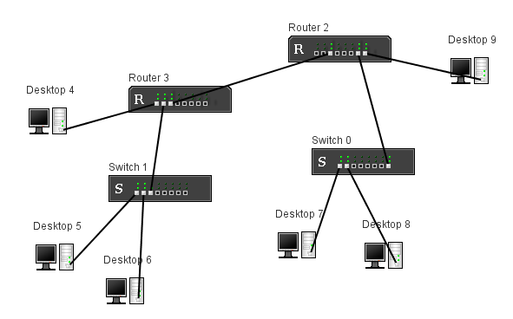В соответствии с планом были размещены указанные виртуальные устройства и соединены кабелем. (Рисунок 1)

Рисунок 1 Топология сети

* 1. 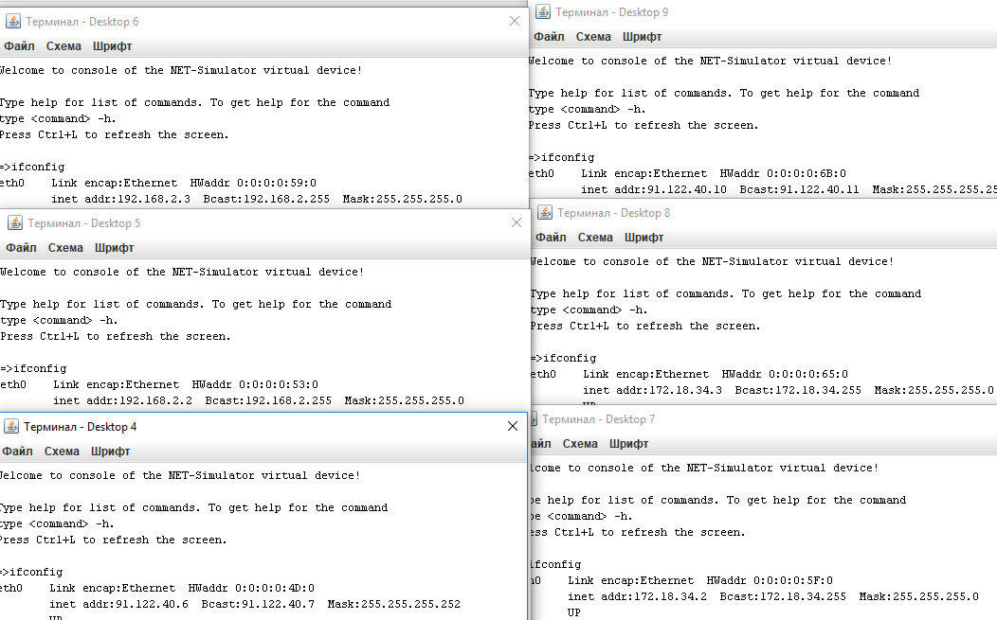Соответствующим ПК были назначены соответствующие IP-адреса. (Рисунок 2)

Рисунок 2 IP адресса

* 1. 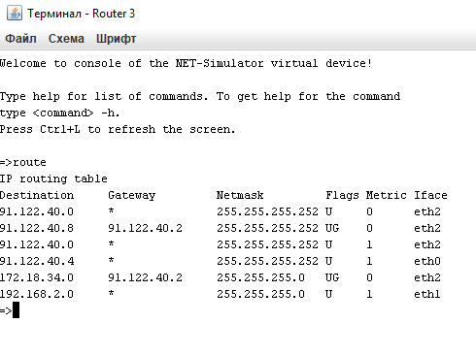С помощью команды route были настроенны правила маршрутизации в сети. Пример таблицы маршрутизации на рисунке 3.

Рисунок 3 Таблица маршрутизации

* 1. 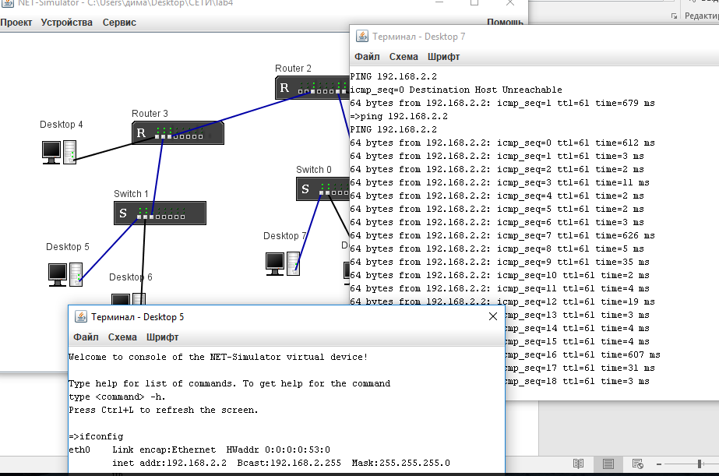Произведененна проверка доступности узлов из одной сети в другую. Рисунок 4.

Рисунок 4 Доступность ПК5 с ПК7

XML – Дополнение

<?xml version="1.0" encoding="UTF-8"?>

<!DOCTYPE project PUBLIC "NET-Simulator/dtd/netsimulator.dtd" "http://www.net-simulator.org/dtd/1.0/netsimulator.dtd">

<project author="" description="" createDate="" currentId="164">

<switchShape id="0" name="Switch 0" description="" x="385" y="185">

<switch id="1">

<port id="2" />

<port id="3" />

<port id="4" />

<port id="5" />

<port id="6" />

<port id="7" />

<port id="8" />

<port id="9" />

</switch>

<socketShape id="10" x="415" y="203" devId="2" />

<socketShape id="11" x="423" y="203" devId="3" />

<socketShape id="12" x="431" y="203" devId="4" />

<socketShape id="13" x="439" y="203" devId="5" />

<socketShape id="14" x="447" y="203" devId="6" />

<socketShape id="15" x="455" y="203" devId="7" />

<socketShape id="16" x="463" y="203" devId="8" />

<socketShape id="17" x="471" y="203" devId="9" />

</switchShape>

<switchShape id="18" name="Switch 1" description="" x="151" y="216">

<switch id="19">

<port id="20" />

<port id="21" />

<port id="22" />

<port id="23" />

<port id="24" />

<port id="25" />

<port id="26" />

<port id="27" />

</switch>

<socketShape id="28" x="181" y="234" devId="20" />

<socketShape id="29" x="189" y="234" devId="21" />

<socketShape id="30" x="197" y="234" devId="22" />

<socketShape id="31" x="205" y="234" devId="23" />

<socketShape id="32" x="213" y="234" devId="24" />

<socketShape id="33" x="221" y="234" devId="25" />

<socketShape id="34" x="229" y="234" devId="26" />

<socketShape id="35" x="237" y="234" devId="27" />

</switchShape>

<routerShape id="36" name="Router 2" description="" x="358" y="55">

<IP4Router id="37">

<eth id="39" name="eth0" status="0" mac="0:0:0:0:25:0" ip4="" ip4bcast="" ip4mask="" bandwidth="0" />

<eth id="40" name="eth1" status="0" mac="0:0:0:0:25:1" ip4="" ip4bcast="" ip4mask="" bandwidth="0" />

<eth id="41" name="eth2" status="1" mac="0:0:0:0:25:2" ip4="91.122.40.2" ip4bcast="91.122.40.3" ip4mask="255.255.255.252" bandwidth="0" />

<eth id="42" name="eth3" status="0" mac="0:0:0:0:25:3" ip4="" ip4bcast="" ip4mask="" bandwidth="0" />

<eth id="43" name="eth4" status="0" mac="0:0:0:0:25:4" ip4="" ip4bcast="" ip4mask="" bandwidth="0" />

<eth id="44" name="eth5" status="0" mac="0:0:0:0:25:5" ip4="" ip4bcast="" ip4mask="" bandwidth="0" />

<eth id="45" name="eth6" status="1" mac="0:0:0:0:25:6" ip4="172.18.34.1" ip4bcast="172.18.34.255" ip4mask="255.255.255.0" bandwidth="0" />

<eth id="46" name="eth7" status="1" mac="0:0:0:0:25:7" ip4="91.122.40.9" ip4bcast="91.122.40.11" ip4mask="255.255.255.252" bandwidth="0" />

<routingTable>

<row target="91.122.40.4" netmask="255.255.255.252" gateway="91.122.40.1" metric="0" iface="eth2" />

<row target="91.122.40.0" netmask="255.255.255.252" gateway="" metric="0" iface="eth2" />

<row target="91.122.40.8" netmask="255.255.255.252" gateway="" metric="1" iface="eth7" />

<row target="192.168.2.0" netmask="255.255.255.0" gateway="91.122.40.1" metric="0" iface="eth2" />

<row target="172.18.34.0" netmask="255.255.255.0" gateway="" metric="0" iface="eth6" />

</routingTable>

</IP4Router>

<socketShape id="48" x="388" y="73" devId="39" />

<socketShape id="49" x="396" y="73" devId="40" />

<socketShape id="50" x="404" y="73" devId="41" />

<socketShape id="51" x="412" y="73" devId="42" />

<socketShape id="52" x="420" y="73" devId="43" />

<socketShape id="53" x="428" y="73" devId="44" />

<socketShape id="54" x="436" y="73" devId="45" />

<socketShape id="55" x="444" y="73" devId="46" />

</routerShape>

<routerShape id="56" name="Router 3" description="" x="174" y="113">

<IP4Router id="57">

<eth id="59" name="eth0" status="1" mac="0:0:0:0:39:0" ip4="91.122.40.5" ip4bcast="91.122.40.7" ip4mask="255.255.255.252" bandwidth="0" />

<eth id="60" name="eth1" status="1" mac="0:0:0:0:39:1" ip4="192.168.2.1" ip4bcast="192.168.2.255" ip4mask="255.255.255.0" bandwidth="0" />

<eth id="61" name="eth2" status="1" mac="0:0:0:0:39:2" ip4="91.122.40.1" ip4bcast="91.122.40.3" ip4mask="255.255.255.252" bandwidth="0" />

<eth id="62" name="eth3" status="0" mac="0:0:0:0:39:3" ip4="" ip4bcast="" ip4mask="" bandwidth="0" />

<eth id="63" name="eth4" status="0" mac="0:0:0:0:39:4" ip4="" ip4bcast="" ip4mask="" bandwidth="0" />

<eth id="64" name="eth5" status="0" mac="0:0:0:0:39:5" ip4="" ip4bcast="" ip4mask="" bandwidth="0" />

<eth id="65" name="eth6" status="0" mac="0:0:0:0:39:6" ip4="" ip4bcast="" ip4mask="" bandwidth="0" />

<eth id="66" name="eth7" status="0" mac="0:0:0:0:39:7" ip4="" ip4bcast="" ip4mask="" bandwidth="0" />

<routingTable>

<row target="91.122.40.8" netmask="255.255.255.252" gateway="91.122.40.2" metric="0" iface="eth2" />

<row target="91.122.40.0" netmask="255.255.255.252" gateway="" metric="0" iface="eth2" />

<row target="91.122.40.4" netmask="255.255.255.252" gateway="" metric="1" iface="eth0" />

<row target="172.18.34.0" netmask="255.255.255.0" gateway="91.122.40.2" metric="0" iface="eth2" />

<row target="192.168.2.0" netmask="255.255.255.0" gateway="" metric="1" iface="eth1" />

</routingTable>

</IP4Router>

<socketShape id="68" x="204" y="131" devId="59" />

<socketShape id="69" x="212" y="131" devId="60" />

<socketShape id="70" x="220" y="131" devId="61" />

<socketShape id="71" x="228" y="131" devId="62" />

<socketShape id="72" x="236" y="131" devId="63" />

<socketShape id="73" x="244" y="131" devId="64" />

<socketShape id="74" x="252" y="131" devId="65" />

<socketShape id="75" x="260" y="131" devId="66" />

</routerShape>

<desktopShape id="76" name="Desktop 4" description="" x="56" y="127">

<IP4Router id="77">

<eth id="79" name="eth0" status="1" mac="0:0:0:0:4D:0" ip4="91.122.40.6" ip4bcast="91.122.40.7" ip4mask="255.255.255.252" bandwidth="0" />

<routingTable>

<row target="91.122.40.0" netmask="255.255.255.252" gateway="91.122.40.5" metric="0" iface="eth0" />

<row target="91.122.40.8" netmask="255.255.255.252" gateway="91.122.40.5" metric="0" iface="eth0" />

<row target="91.122.40.4" netmask="255.255.255.252" gateway="" metric="1" iface="eth0" />

<row target="172.18.34.0" netmask="255.255.255.0" gateway="91.122.40.5" metric="0" iface="eth0" />

<row target="192.168.2.0" netmask="255.255.255.0" gateway="91.122.40.5" metric="0" iface="eth0" />

</routingTable>

</IP4Router>

<socketShape id="81" x="94" y="162" devId="79" />

</desktopShape>

<desktopShape id="82" name="Desktop 5" description="" x="64" y="284">

<IP4Router id="83">

<eth id="85" name="eth0" status="1" mac="0:0:0:0:53:0" ip4="192.168.2.2" ip4bcast="192.168.2.255" ip4mask="255.255.255.0" bandwidth="0" />

<routingTable>

<row target="91.122.40.4" netmask="255.255.255.252" gateway="192.168.2.1" metric="0" iface="eth0" />

<row target="91.122.40.0" netmask="255.255.255.0" gateway="192.168.2.1" metric="0" iface="eth0" />

<row target="172.18.34.0" netmask="255.255.255.0" gateway="192.168.2.1" metric="0" iface="eth0" />

<row target="192.168.2.0" netmask="255.255.255.0" gateway="" metric="1" iface="eth0" />

</routingTable>

</IP4Router>

<socketShape id="87" x="102" y="319" devId="85" />

</desktopShape>

<desktopShape id="88" name="Desktop 6" description="" x="145" y="323">

<IP4Router id="89">

<eth id="91" name="eth0" status="1" mac="0:0:0:0:59:0" ip4="192.168.2.3" ip4bcast="192.168.2.255" ip4mask="255.255.255.0" bandwidth="0" />

<routingTable>

<row target="91.122.40.4" netmask="255.255.255.252" gateway="192.168.2.1" metric="0" iface="eth0" />

<row target="91.122.40.0" netmask="255.255.255.0" gateway="192.168.2.1" metric="0" iface="eth0" />

<row target="172.18.34.0" netmask="255.255.255.0" gateway="192.168.2.1" metric="0" iface="eth0" />

<row target="192.168.2.0" netmask="255.255.255.0" gateway="" metric="1" iface="eth0" />

</routingTable>

</IP4Router>

<socketShape id="93" x="183" y="358" devId="91" />

</desktopShape>

<desktopShape id="94" name="Desktop 7" description="" x="343" y="270">

<IP4Router id="95">

<eth id="97" name="eth0" status="1" mac="0:0:0:0:5F:0" ip4="172.18.34.2" ip4bcast="172.18.34.255" ip4mask="255.255.255.0" bandwidth="0" />

<routingTable>

<row target="91.122.40.4" netmask="255.255.255.252" gateway="172.18.34.1" metric="0" iface="eth0" />

<row target="91.122.40.0" netmask="255.255.255.252" gateway="172.18.34.1" metric="0" iface="eth0" />

<row target="91.122.40.8" netmask="255.255.255.252" gateway="172.18.34.1" metric="0" iface="eth0" />

<row target="192.168.2.0" netmask="255.255.255.0" gateway="172.18.34.1" metric="0" iface="eth0" />

<row target="172.18.34.0" netmask="255.255.255.0" gateway="" metric="1" iface="eth0" />

</routingTable>

</IP4Router>

<socketShape id="99" x="381" y="305" devId="97" />

</desktopShape>

<desktopShape id="100" name="Desktop 8" description="" x="443" y="282">

<IP4Router id="101">

<eth id="103" name="eth0" status="1" mac="0:0:0:0:65:0" ip4="172.18.34.3" ip4bcast="172.18.34.255" ip4mask="255.255.255.0" bandwidth="0" />

<routingTable>

<row target="91.122.40.4" netmask="255.255.255.252" gateway="172.18.34.1" metric="0" iface="eth0" />

<row target="91.122.40.0" netmask="255.255.255.252" gateway="172.18.34.1" metric="0" iface="eth0" />

<row target="91.122.40.8" netmask="255.255.255.252" gateway="172.18.34.1" metric="0" iface="eth0" />

<row target="192.168.2.0" netmask="255.255.255.0" gateway="172.18.34.1" metric="0" iface="eth0" />

<row target="172.18.34.0" netmask="255.255.255.0" gateway="" metric="1" iface="eth0" />

</routingTable>

</IP4Router>

<socketShape id="105" x="481" y="317" devId="103" />

</desktopShape>

<desktopShape id="106" name="Desktop 9" description="" x="542" y="69">

<IP4Router id="107">

<eth id="109" name="eth0" status="1" mac="0:0:0:0:6B:0" ip4="91.122.40.10" ip4bcast="91.122.40.11" ip4mask="255.255.255.252" bandwidth="0" />

<routingTable>

<row target="91.122.40.0" netmask="255.255.255.252" gateway="91.122.40.9" metric="0" iface="eth0" />

<row target="91.122.40.4" netmask="255.255.255.252" gateway="91.122.40.9" metric="0" iface="eth0" />

<row target="91.122.40.8" netmask="255.255.255.252" gateway="" metric="1" iface="eth0" />

<row target="192.168.2.0" netmask="255.255.255.0" gateway="91.122.40.9" metric="0" iface="eth0" />

<row target="172.18.34.0" netmask="255.255.255.0" gateway="91.122.40.9" metric="0" iface="eth0" />

</routingTable>

</IP4Router>

<socketShape id="111" x="580" y="104" devId="109" />

</desktopShape>

<patchcord id="112">

<media id="113" pointsCount="2" />

<plug id="114" point="1" x="94" y="162" socket="81" />

<plug id="115" point="2" x="204" y="131" socket="68" />

</patchcord>

<patchcord id="116">

<media id="117" pointsCount="2" />

<plug id="118" point="1" x="102" y="319" socket="87" />

<plug id="119" point="2" x="181" y="234" socket="28" />

</patchcord>

<patchcord id="120">

<media id="121" pointsCount="2" />

<plug id="122" point="1" x="183" y="358" socket="93" />

<plug id="123" point="2" x="189" y="234" socket="29" />

</patchcord>

<patchcord id="124">

<media id="125" pointsCount="2" />

<plug id="126" point="1" x="197" y="234" socket="30" />

<plug id="127" point="2" x="212" y="131" socket="69" />

</patchcord>

<patchcord id="128">

<media id="129" pointsCount="2" />

<plug id="130" point="1" x="444" y="73" socket="55" />

<plug id="131" point="2" x="580" y="104" socket="111" />

</patchcord>

<patchcord id="132">

<media id="133" pointsCount="2" />

<plug id="134" point="1" x="436" y="73" socket="54" />

<plug id="135" point="2" x="471" y="203" socket="17" />

</patchcord>

<patchcord id="136">

<media id="137" pointsCount="2" />

<plug id="138" point="1" x="415" y="203" socket="10" />

<plug id="139" point="2" x="381" y="305" socket="99" />

</patchcord>

<patchcord id="140">

<media id="141" pointsCount="2" />

<plug id="142" point="1" x="423" y="203" socket="11" />

<plug id="143" point="2" x="481" y="317" socket="105" />

</patchcord>

<patchcord id="144">

<media id="145" pointsCount="2" />

<plug id="146" point="1" x="220" y="131" socket="70" />

<plug id="147" point="2" x="404" y="73" socket="50" />

</patchcord>

</project>

HTML – Дополнение

<html>

<head>

<META http-equiv="Content-Type" content="text/html; charset=UTF-8">

<title>NET-Simulator Project Report</title>

</head>

<body>

<h1>NET-Simulator Project Report</h1>

<strong>Project file:</strong> C:\Users\РґРёРјР°\Desktop\РЎР•РўР\lab4<br>

<strong>Author:</strong>

<br>

<strong>Description:</strong>

<br>

<strong>Project created at:</strong>

<br>

<strong>Report generated at:</strong> 2017-10-10 12:43:44<br>

<img alt="" src="html4.png"><br>

<h2>Switch</h2>

<table cellpadding="1" cellspacing="0" border="1" width="600">

<tr>

<th width="20%" align="left">Name:</th><td>Switch 0</td>

</tr>

<tr>

<th width="20%" align="left">Description:</th><td>&nbsp;</td>

</tr>

</table>

<h2>Switch</h2>

<table cellpadding="1" cellspacing="0" border="1" width="600">

<tr>

<th width="20%" align="left">Name:</th><td>Switch 1</td>

</tr>

<tr>

<th width="20%" align="left">Description:</th><td>&nbsp;</td>

</tr>

</table>

<h2>Router</h2>

<table cellpadding="1" cellspacing="0" border="1" width="600">

<tr>

<th width="20%" align="left">Name:</th><td>Router 2</td>

</tr>

<tr>

<th width="20%" align="left">Description:</th><td>&nbsp;</td>

</tr>

</table>

<h3>Interfaces:</h3>

<table cellpadding="1" cellspacing="0" border="1" width="600">

<tr>

<th>Name</th><th>Status</th><th>IP Address</th><th>Netmask</th><th>Broadcast</th>

</tr>

<tr>

<td>eth0</td><td>DOWN</td><td>&nbsp;</td><td>&nbsp;</td><td>&nbsp;</td>

</tr>

<tr>

<td>eth1</td><td>DOWN</td><td>&nbsp;</td><td>&nbsp;</td><td>&nbsp;</td>

</tr>

<tr>

<td>eth2</td><td>UP</td><td>91.122.40.2</td><td>255.255.255.252</td><td>91.122.40.3</td>

</tr>

<tr>

<td>eth3</td><td>DOWN</td><td>&nbsp;</td><td>&nbsp;</td><td>&nbsp;</td>

</tr>

<tr>

<td>eth4</td><td>DOWN</td><td>&nbsp;</td><td>&nbsp;</td><td>&nbsp;</td>

</tr>

<tr>

<td>eth5</td><td>DOWN</td><td>&nbsp;</td><td>&nbsp;</td><td>&nbsp;</td>

</tr>

<tr>

<td>eth6</td><td>UP</td><td>172.18.34.1</td><td>255.255.255.0</td><td>172.18.34.255</td>

</tr>

<tr>

<td>eth7</td><td>UP</td><td>91.122.40.9</td><td>255.255.255.252</td><td>91.122.40.11</td>

</tr>

</table>

<h3>Routing table:</h3>

<table cellpadding="1" cellspacing="0" border="1" width="600">

<tr>

<th>Target</th><th>Netmask</th><th>Gateway</th><th>Metric</th><th>Interface</th>

</tr>

<tr>

<td>91.122.40.0</td><td>255.255.255.252</td><td>*</td><td align="right">0</td><td>eth2</td>

</tr>

<tr>

<td>91.122.40.4</td><td>255.255.255.252</td><td>91.122.40.1</td><td align="right">0</td><td>eth2</td>

</tr>

<tr>

<td>91.122.40.8</td><td>255.255.255.252</td><td>*</td><td align="right">1</td><td>eth7</td>

</tr>

<tr>

<td>91.122.40.0</td><td>255.255.255.252</td><td>*</td><td align="right">1</td><td>eth2</td>

</tr>

<tr>

<td>172.18.34.0</td><td>255.255.255.0</td><td>*</td><td align="right">0</td><td>eth6</td>

</tr>

<tr>

<td>192.168.2.0</td><td>255.255.255.0</td><td>91.122.40.1</td><td align="right">0</td><td>eth2</td>

</tr>

<tr>

<td>172.18.34.0</td><td>255.255.255.0</td><td>*</td><td align="right">1</td><td>eth6</td>

</tr>

</table>

<h2>Router</h2>

<table cellpadding="1" cellspacing="0" border="1" width="600">

<tr>

<th width="20%" align="left">Name:</th><td>Router 3</td>

</tr>

<tr>

<th width="20%" align="left">Description:</th><td>&nbsp;</td>

</tr>

</table>

<h3>Interfaces:</h3>

<table cellpadding="1" cellspacing="0" border="1" width="600">

<tr>

<th>Name</th><th>Status</th><th>IP Address</th><th>Netmask</th><th>Broadcast</th>

</tr>

<tr>

<td>eth0</td><td>UP</td><td>91.122.40.5</td><td>255.255.255.252</td><td>91.122.40.7</td>

</tr>

<tr>

<td>eth1</td><td>UP</td><td>192.168.2.1</td><td>255.255.255.0</td><td>192.168.2.255</td>

</tr>

<tr>

<td>eth2</td><td>UP</td><td>91.122.40.1</td><td>255.255.255.252</td><td>91.122.40.3</td>

</tr>

<tr>

<td>eth3</td><td>DOWN</td><td>&nbsp;</td><td>&nbsp;</td><td>&nbsp;</td>

</tr>

<tr>

<td>eth4</td><td>DOWN</td><td>&nbsp;</td><td>&nbsp;</td><td>&nbsp;</td>

</tr>

<tr>

<td>eth5</td><td>DOWN</td><td>&nbsp;</td><td>&nbsp;</td><td>&nbsp;</td>

</tr>

<tr>

<td>eth6</td><td>DOWN</td><td>&nbsp;</td><td>&nbsp;</td><td>&nbsp;</td>

</tr>

<tr>

<td>eth7</td><td>DOWN</td><td>&nbsp;</td><td>&nbsp;</td><td>&nbsp;</td>

</tr>

</table>

<h3>Routing table:</h3>

<table cellpadding="1" cellspacing="0" border="1" width="600">

<tr>

<th>Target</th><th>Netmask</th><th>Gateway</th><th>Metric</th><th>Interface</th>

</tr>

<tr>

<td>91.122.40.0</td><td>255.255.255.252</td><td>*</td><td align="right">0</td><td>eth2</td>

</tr>

<tr>

<td>91.122.40.8</td><td>255.255.255.252</td><td>91.122.40.2</td><td align="right">0</td><td>eth2</td>

</tr>

<tr>

<td>91.122.40.0</td><td>255.255.255.252</td><td>*</td><td align="right">1</td><td>eth2</td>

</tr>

<tr>

<td>91.122.40.4</td><td>255.255.255.252</td><td>*</td><td align="right">1</td><td>eth0</td>

</tr>

<tr>

<td>172.18.34.0</td><td>255.255.255.0</td><td>91.122.40.2</td><td align="right">0</td><td>eth2</td>

</tr>

<tr>

<td>192.168.2.0</td><td>255.255.255.0</td><td>*</td><td align="right">1</td><td>eth1</td>

</tr>

</table>

<h2>Desktop</h2>

<table cellpadding="1" cellspacing="0" border="1" width="600">

<tr>

<th width="20%" align="left">Name:</th><td>Desktop 4</td>

</tr>

<tr>

<th width="20%" align="left">Description:</th><td>&nbsp;</td>

</tr>

</table>

<h3>Interfaces:</h3>

<table cellpadding="1" cellspacing="0" border="1" width="600">

<tr>

<th>Name</th><th>Status</th><th>IP Address</th><th>Netmask</th><th>Broadcast</th>

</tr>

<tr>

<td>eth0</td><td>UP</td><td>91.122.40.6</td><td>255.255.255.252</td><td>91.122.40.7</td>

</tr>

</table>

<h3>Routing table:</h3>

<table cellpadding="1" cellspacing="0" border="1" width="600">

<tr>

<th>Target</th><th>Netmask</th><th>Gateway</th><th>Metric</th><th>Interface</th>

</tr>

<tr>

<td>91.122.40.8</td><td>255.255.255.252</td><td>91.122.40.5</td><td align="right">0</td><td>eth0</td>

</tr>

<tr>

<td>91.122.40.0</td><td>255.255.255.252</td><td>91.122.40.5</td><td align="right">0</td><td>eth0</td>

</tr>

<tr>

<td>91.122.40.4</td><td>255.255.255.252</td><td>*</td><td align="right">1</td><td>eth0</td>

</tr>

<tr>

<td>192.168.2.0</td><td>255.255.255.0</td><td>91.122.40.5</td><td align="right">0</td><td>eth0</td>

</tr>

<tr>

<td>172.18.34.0</td><td>255.255.255.0</td><td>91.122.40.5</td><td align="right">0</td><td>eth0</td>

</tr>

</table>

<h2>Desktop</h2>

<table cellpadding="1" cellspacing="0" border="1" width="600">

<tr>

<th width="20%" align="left">Name:</th><td>Desktop 5</td>

</tr>

<tr>

<th width="20%" align="left">Description:</th><td>&nbsp;</td>

</tr>

</table>

<h3>Interfaces:</h3>

<table cellpadding="1" cellspacing="0" border="1" width="600">

<tr>

<th>Name</th><th>Status</th><th>IP Address</th><th>Netmask</th><th>Broadcast</th>

</tr>

<tr>

<td>eth0</td><td>UP</td><td>192.168.2.2</td><td>255.255.255.0</td><td>192.168.2.255</td>

</tr>

</table>

<h3>Routing table:</h3>

<table cellpadding="1" cellspacing="0" border="1" width="600">

<tr>

<th>Target</th><th>Netmask</th><th>Gateway</th><th>Metric</th><th>Interface</th>

</tr>

<tr>

<td>91.122.40.4</td><td>255.255.255.252</td><td>192.168.2.1</td><td align="right">0</td><td>eth0</td>

</tr>

<tr>

<td>172.18.34.0</td><td>255.255.255.0</td><td>192.168.2.1</td><td align="right">0</td><td>eth0</td>

</tr>

<tr>

<td>91.122.40.0</td><td>255.255.255.0</td><td>192.168.2.1</td><td align="right">0</td><td>eth0</td>

</tr>

<tr>

<td>192.168.2.0</td><td>255.255.255.0</td><td>*</td><td align="right">1</td><td>eth0</td>

</tr>

</table>

<h2>Desktop</h2>

<table cellpadding="1" cellspacing="0" border="1" width="600">

<tr>

<th width="20%" align="left">Name:</th><td>Desktop 6</td>

</tr>

<tr>

<th width="20%" align="left">Description:</th><td>&nbsp;</td>

</tr>

</table>

<h3>Interfaces:</h3>

<table cellpadding="1" cellspacing="0" border="1" width="600">

<tr>

<th>Name</th><th>Status</th><th>IP Address</th><th>Netmask</th><th>Broadcast</th>

</tr>

<tr>

<td>eth0</td><td>UP</td><td>192.168.2.3</td><td>255.255.255.0</td><td>192.168.2.255</td>

</tr>

</table>

<h3>Routing table:</h3>

<table cellpadding="1" cellspacing="0" border="1" width="600">

<tr>

<th>Target</th><th>Netmask</th><th>Gateway</th><th>Metric</th><th>Interface</th>

</tr>

<tr>

<td>91.122.40.4</td><td>255.255.255.252</td><td>192.168.2.1</td><td align="right">0</td><td>eth0</td>

</tr>

<tr>

<td>172.18.34.0</td><td>255.255.255.0</td><td>192.168.2.1</td><td align="right">0</td><td>eth0</td>

</tr>

<tr>

<td>91.122.40.0</td><td>255.255.255.0</td><td>192.168.2.1</td><td align="right">0</td><td>eth0</td>

</tr>

<tr>

<td>192.168.2.0</td><td>255.255.255.0</td><td>*</td><td align="right">1</td><td>eth0</td>

</tr>

</table>

<h2>Desktop</h2>

<table cellpadding="1" cellspacing="0" border="1" width="600">

<tr>

<th width="20%" align="left">Name:</th><td>Desktop 7</td>

</tr>

<tr>

<th width="20%" align="left">Description:</th><td>&nbsp;</td>

</tr>

</table>

<h3>Interfaces:</h3>

<table cellpadding="1" cellspacing="0" border="1" width="600">

<tr>

<th>Name</th><th>Status</th><th>IP Address</th><th>Netmask</th><th>Broadcast</th>

</tr>

<tr>

<td>eth0</td><td>UP</td><td>172.18.34.2</td><td>255.255.255.0</td><td>172.18.34.255</td>

</tr>

</table>

<h3>Routing table:</h3>

<table cellpadding="1" cellspacing="0" border="1" width="600">

<tr>

<th>Target</th><th>Netmask</th><th>Gateway</th><th>Metric</th><th>Interface</th>

</tr>

<tr>

<td>91.122.40.8</td><td>255.255.255.252</td><td>172.18.34.1</td><td align="right">0</td><td>eth0</td>

</tr>

<tr>

<td>91.122.40.0</td><td>255.255.255.252</td><td>172.18.34.1</td><td align="right">0</td><td>eth0</td>

</tr>

<tr>

<td>91.122.40.4</td><td>255.255.255.252</td><td>172.18.34.1</td><td align="right">0</td><td>eth0</td>

</tr>

<tr>

<td>192.168.2.0</td><td>255.255.255.0</td><td>172.18.34.1</td><td align="right">0</td><td>eth0</td>

</tr>

<tr>

<td>172.18.34.0</td><td>255.255.255.0</td><td>*</td><td align="right">1</td><td>eth0</td>

</tr>

</table>

<h2>Desktop</h2>

<table cellpadding="1" cellspacing="0" border="1" width="600">

<tr>

<th width="20%" align="left">Name:</th><td>Desktop 8</td>

</tr>

<tr>

<th width="20%" align="left">Description:</th><td>&nbsp;</td>

</tr>

</table>

<h3>Interfaces:</h3>

<table cellpadding="1" cellspacing="0" border="1" width="600">

<tr>

<th>Name</th><th>Status</th><th>IP Address</th><th>Netmask</th><th>Broadcast</th>

</tr>

<tr>

<td>eth0</td><td>UP</td><td>172.18.34.3</td><td>255.255.255.0</td><td>172.18.34.255</td>

</tr>

</table>

<h3>Routing table:</h3>

<table cellpadding="1" cellspacing="0" border="1" width="600">

<tr>

<th>Target</th><th>Netmask</th><th>Gateway</th><th>Metric</th><th>Interface</th>

</tr>

<tr>

<td>91.122.40.8</td><td>255.255.255.252</td><td>172.18.34.1</td><td align="right">0</td><td>eth0</td>

</tr>

<tr>

<td>91.122.40.0</td><td>255.255.255.252</td><td>172.18.34.1</td><td align="right">0</td><td>eth0</td>

</tr>

<tr>

<td>91.122.40.4</td><td>255.255.255.252</td><td>172.18.34.1</td><td align="right">0</td><td>eth0</td>

</tr>

<tr>

<td>192.168.2.0</td><td>255.255.255.0</td><td>172.18.34.1</td><td align="right">0</td><td>eth0</td>

</tr>

<tr>

<td>172.18.34.0</td><td>255.255.255.0</td><td>*</td><td align="right">1</td><td>eth0</td>

</tr>

</table>

<h2>Desktop</h2>

<table cellpadding="1" cellspacing="0" border="1" width="600">

<tr>

<th width="20%" align="left">Name:</th><td>Desktop 9</td>

</tr>

<tr>

<th width="20%" align="left">Description:</th><td>&nbsp;</td>

</tr>

</table>

<h3>Interfaces:</h3>

<table cellpadding="1" cellspacing="0" border="1" width="600">

<tr>

<th>Name</th><th>Status</th><th>IP Address</th><th>Netmask</th><th>Broadcast</th>

</tr>

<tr>

<td>eth0</td><td>UP</td><td>91.122.40.10</td><td>255.255.255.252</td><td>91.122.40.11</td>

</tr>

</table>

<h3>Routing table:</h3>

<table cellpadding="1" cellspacing="0" border="1" width="600">

<tr>

<th>Target</th><th>Netmask</th><th>Gateway</th><th>Metric</th><th>Interface</th>

</tr>

<tr>

<td>91.122.40.4</td><td>255.255.255.252</td><td>91.122.40.9</td><td align="right">0</td><td>eth0</td>

</tr>

<tr>

<td>91.122.40.0</td><td>255.255.255.252</td><td>91.122.40.9</td><td align="right">0</td><td>eth0</td>

</tr>

<tr>

<td>91.122.40.8</td><td>255.255.255.252</td><td>*</td><td align="right">1</td><td>eth0</td>

</tr>

<tr>

<td>172.18.34.0</td><td>255.255.255.0</td><td>91.122.40.9</td><td align="right">0</td><td>eth0</td>

</tr>

<tr>

<td>192.168.2.0</td><td>255.255.255.0</td><td>91.122.40.9</td><td align="right">0</td><td>eth0</td>

</tr>

</table>

</body>

</html>

**Выводы:**

В данной лабораторной работе я научился использовать маршрутизаторы в сетях и производить настройку маршрутизации в сети.